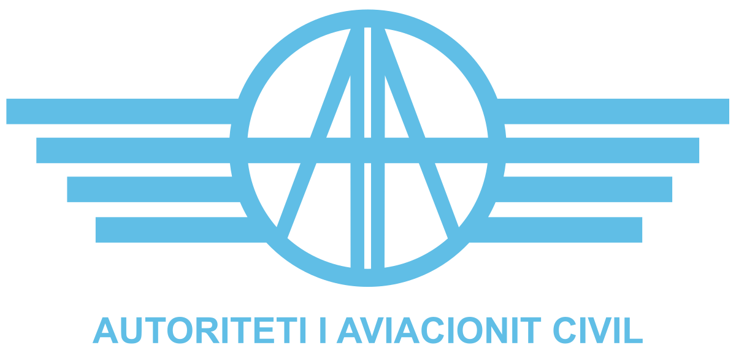

CALL FOR EXPRESSION OF INTEREST

EXTERNAL SECURITY EXPERT FOR ACAA

February 2025

Introduction

Albanian Civil Aviation Authority, (hereinafter “ACAA” or “the Contracting Authority”) is a public legal body, established by law No. 53/2022, “For the organization and functioning of Civil Aviation Authority”, which has been given specific regulatory and oversight tasks in the field of civil aviation transport in the Republic of Albania.
A contracted expert is needed for Albanian CAA considering the latest changes in infrastructure and implementation of new standards of security equipment and other new software’s. Also, in the face of ACAA priorities, one of them, related to implementation of One Stop Security process, it is considered that a technical expertise is needed for the evaluation of existing security system and providing necessary guidance.

Objectives
  - Main objectives

The objective of these Terms of Reference is to contract an individual expert who has the necessary qualification, experience and background related to aviation security and more specifically related to implementation of EU Regulations in the field of aviation security and more specifically COMMISSION IMPLEMENTING REGULATION (EU) 2015/1998 of 5 November 2015 laying down detailed measures for the implementation of the common basic standards on aviation security and REGULATION (EC) No 300/2008 OF THE EUROPEAN PARLIAMENT AND OF THE COUNCIL of 11 March 2008 on common rules in the field of civil aviation security and repealing Regulation (EC) No 2320/2002

Specific Objectives

The specific objectives to be performed by the contracted expert will be:

- Reviewing and assessing technical documentation related to aviation security.
- Carrying evaluations on current access control systems at Tirana International Airport and providing technical feedback.
- Preparation of relevant reports and respective tasks to be followed up.

Specific Tasks

The following specific task should be undertaken by the expert:

- Evaluation of national regulations and legislation
- Evaluation of Airport Security Program
- Evaluation of Risk Methodology
- Assessment of access control system and electronic version
- Preparing ACAA from a smooth transition when establishing the regime and ensuring no disrupt in operation.
- Identification of risks associated with the transition and mitigation measures to be taken.
- Identification of security needs to be considered in implementing new access control system and best practice on how to implement access control systems;

Expected Deliverables

The contracted expert in support to DAS staff, during the contracted period shall conduct on behalf of ACAA, the following tasks:

- Evaluation and assessment of access control system
- Draft report on vulnerabilities and possible improvements
- Evaluation or Risk Assessment Methodology – report on current methodology
- Review of national legislation – report on National Civil Aviation Security Program compliance with international and European standards.
- Review of Airport Security Program – report on its compliance with national and international standards

5. Time of implementation

The contracted expert as Security Expert, will be available upon ACAA request in specific cases. The period of implementation of this contract will be six months.
The contracted expert shall perform the above tasks in 31 working days always in cooperation with the Directory of Aviation Security staff of ACAA.

If the subject of the relevant task allows the expert to perform it remotely, both parties (Expert and
ACAA) agree in performing it remotely.

- For the evaluation of national programs, to assess their compliance with the relevant EU regulations cited above are evaluated an overage of 15 working days per contracted period.
- For the evaluation of Risk Assessment Methodology are evaluated an average of 6 working days
- For the onsite tasks, evaluation of access control system and electronic system, are evaluated an average of 3 working days per contracted period.
- Drafting of report and recommendations, 7 working days per contracted period.

6. Place of Delivery

Place of delivery shall be defined for each specific task/ activity, however in general services shall be performed in Tirana, Albania, premises of ACAA and online.

7. Remuneration & Reimbursement of Expenses Fees

7.1 Fees

The daily fee applicable for the contract will be 285 Euro/per day

7.2 Per diem

In addition, experts performing tasks outside their place of residence may be entitled to a flat rate subsistence allowance and reimbursement for travel expenses.
The subsistence allowance (per diem) is paid as a flat rate and is considered to cover all expenses incurred at the place of the meeting or assignment, including the costs of accommodation, meals and local travel.

The amount of the subsistence allowance is the standard rate published by the European Commission (https://international-partnerships.ec.europa.eu/system/files/2022-09/Per%20diem%20rates%20-%2025%20July%202022.pdf) for the country where the assignment takes place.

The full amount will be paid for assignments of more than one day for those days which include an overnight stay. For one-day assignments, 25 % of a full per diem will be paid.

For the day of return (which thus includes no overnight stay) from assignments of more than one day (which include overnight stay), and when the return to the point of departure is later than 8 p.m., 25 % of a full per diem will be paid.

7.3 Travel expenses

Travel expenses are reimbursed on the following basis:

- international travel from the place of residence of the expert (point of departure) to the location of the assignment;
- In economy class, at the lowest rates available at the moment of the notification of the assignment, taking into account the time and/or special features of the assignment.

The following supporting documents need to be provided and submitted to the responsible staff member within the ACAA:

- the ticket or electronic booking;
- the travel agency’s invoice (when applicable) or other prove of payment;
- the boarding pass(es);

ACAA reserves the right to reject payment of travel expenditures if the most direct route and the most economical fare criteria have not been applied.

8. Reporting
The language of communication for the assignment shall be English. The Inspector will produce the documents in both electronic and hard copy formats, as Microsoft Word documents, and submit them to the ACAA for each task performed.

9. Selection Criteria

The expert undertaking the above-mentioned tasks shall meet the following minimum requirements below:

- The security expert should have at least ten-year experience in aviation security and operations related to security;
- Qualification and training in the field of aviation security;
- Experience in managerial level;
- Experience in managing projects related to changes in technology and infrastructure and their impact on aviation security (at least one);
- Proved knowledge on risk assessment in aviation security and quality control

10. Exclusion Criteria

Participation in this call is only open to natural persons who are not in any of the situations listed below, in particular:

- Bankrupt, subject to insolvency or being wound up, are having their affairs administered by a liquidator or by courts, have entered into an arrangement with creditors, have suspended business activities, are the subject of proceedings concerning those matters, or are in any analogous situation arising from a similar procedure provided for under national legislation or Union law;
- Convicted of an offence concerning their professional misconduct by an administrative decision or a judgement of a competent authority of a Member State which has the force of res judicata;
- Guilty of grave professional misconduct proven by any means which the Contracting Authority can justify
- Not in compliance with their obligations relating to the payment of social security contributions or the payment of taxes in accordance with the legal provisions of the country in which they are established or with those of the country of the Contracting Authority or those of the country where the contract is to be performed;
- Subject to a judgement which has the force of res judicata for fraud, corruption, involvement in a criminal organization, money laundering or terrorist financing or any other illegal activity.
- Subject to an administrative penalty for being guilty of misrepresenting the information required by the contracting authority as a condition of participation in the procurement procedure or fail to supply that information or for having been declared to be in serious breach of their obligations under contracts by the budget, or have created an entity in a different jurisdiction with the intent to circumvent legal obligations in the jurisdiction.
In addition to the above, contracts may not be awarded to experts who, during the call, are:
- Subject to a Conflict of interests
- Guilty of misrepresentation in supplying the information required by the Contracting Authority as a condition of participation in the call or fail to supply this information.

11. Confidentiality, Independence and Absence of Conflict of Interest

All experts are expected to ensure that their contractual and professional obligations in particular with regard to confidentiality, independence and absence of conflict of interests are well understood and upheld throughout and after any contract assignment.

At the time of contract assignment, the expert must sign a declaration of ‘Confidentiality, Independence and Absence of Conflict of Interests’ (Annex II to the draft contract) before contract signature.

12. Required documentation
Applications must include all the documents listed below:
- Curriculum Vitae in EU format;
- Copy of Diploma
- List of the trainings and qualifications with the period of validity and notarized copy;
- Applicants must confirm in their application that they are not in any of the situations listed in section 10 – exclusion criteria;
- Applicants should justify how they fulfil the minimum criteria such as 10 years of relevant work experience. As evidence one or more activities and assignments relevant to the scope of area shall be provided.

It is strictly required that applications are submitted in the requested format and include all information/documentation necessary to enable the ACAA to assess them. Failure to respect these requirements may result in the rejection of the application.

Before awarding a contract, the ACAA reserves the right to request any additional supporting documentation in order to verify the applicant’s qualifications, professional experience and/or language capabilities (i.e. copies certificates, diplomas, references etc.).

Please also note that before contract assignment the ACAA may request an interview in order to establish a first contact with the expert and/or assess / verify any information provided in the application.

13. Application Process
Applications must include all the documents listed below and must be submitted using the official e-mail of ACAA (info@acaa.gov.al), before 21st of February 2025, at 16:30 (GMT+1).

It is strictly required that applications are submitted in the requested format and include all information/documentation necessary to enable the ACAA to assess them. Failure to respect these requirements may result in the rejection of the application.

Before awarding a contract, the ACAA reserves the right to request any additional supporting documentation in order to verify the applicant’s qualifications, professional experience and/or language capabilities (i.e. copies of licenses, certificates, diplomas, references etc.).

Please also note that before contract assignment the ACAA may request a virtual interview in order to establish a first contact with the expert and/or assess / verify any information provided in the application.

Applicants may submit questions by e-mail to the following address up to 5 days before the deadline for submission of applications.
info@acaa.gov.al
Subject: Call for application for External Expert Security Expert for ACAA

14. Documents needed for Contract Signature
Before contract signature, the expert shall be required to submit the following documentation, within 5 days of notification, duly completed, signed and in original:
- Annex II, “Declaration of Confidentiality, Independence and Absence of Conflict of Interests”.
- Annex III, Financial Identification Form - using the template attached, including the IBAN and SWIFT/BIC code, indicating the bank account to which payments should be made.
- Annex IV, Legal Entity Form - the form applicable for natural persons attached to this notice.

